Oracle Recruiting Cloud: Candidate Job Submission
This walkthrough will show candidates who already have a profile in Oracle Cloud Recruiting how to apply to a position:
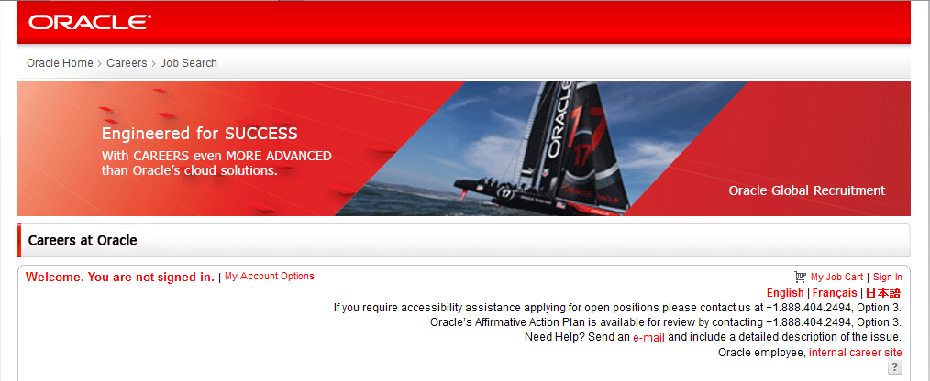
Existing Candidate – Job Submission
- Click the sign in button on the right hand side of the screen.

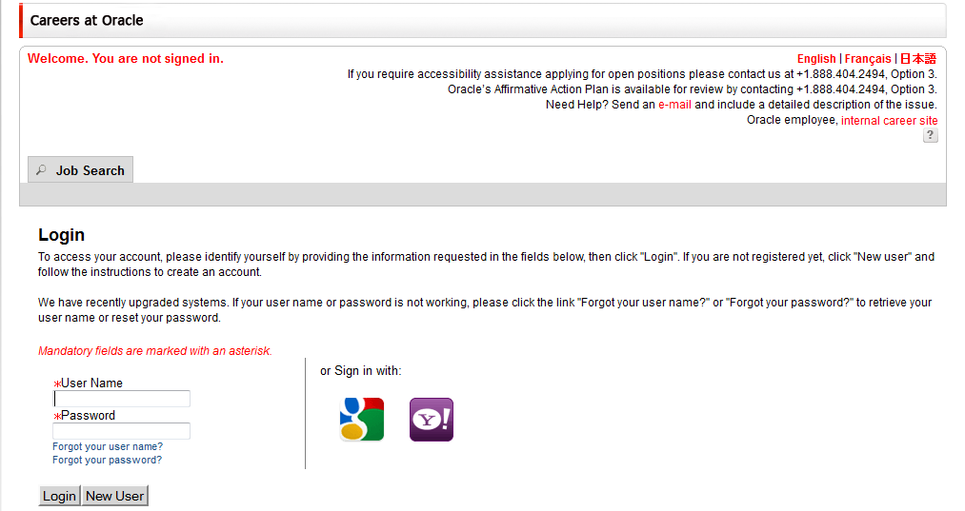
- Enter in your username and password information and then click Sign In. If you have forgotten your user information use the “Forgot your…” links.

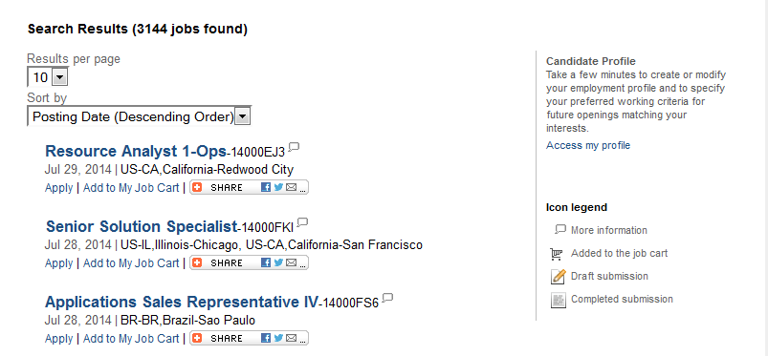
- Use the search options at the top of the page to search for new opportunties.
- Click the job title that you would like to review the job description. In the new window, click Apply Online to begin your application process.
- Review the Privacy statement and click Accept if you agree to the terms.

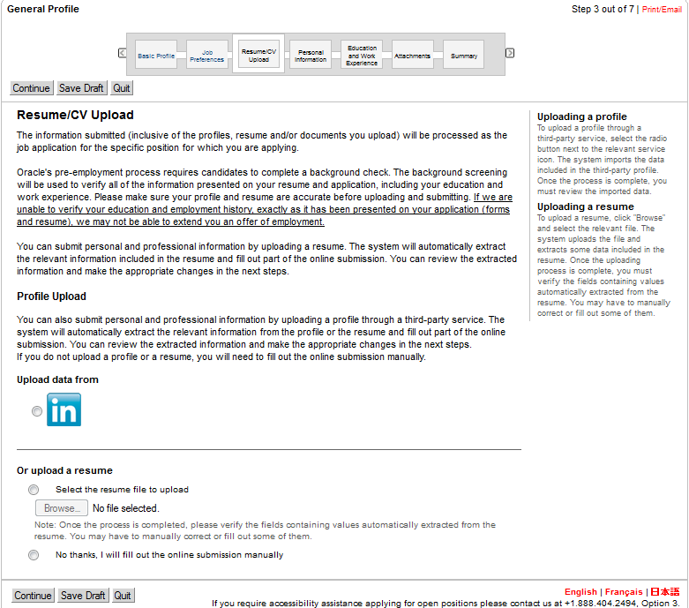
- You will be asked to review your basic profile information. Select a Source Type in the drop down to tell us how you heard about this specific position. Review the remaining information and make edits if necessary. Click Continue.
- In this next area, you have the option to attach a resume. If a resume is uploaded, your information will automatically parse over. To add a resume, select the radial button that’s states “Select Resume File to Upload.” Click Browse to add your file, then click Continue. If you have recently created your general profile and have no new updates, click the radial button next to “No thanks…”
- Confirm your personal information and make adjustments where necessary. Click Continue.
- Review your Education and Work Experience. Make updates as needed. Click Continue.
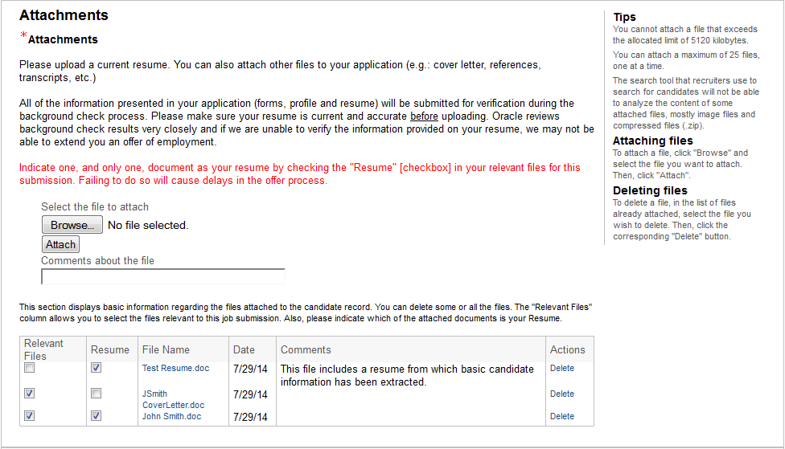
- In the resume section, read the instructions very carefully. Click Browse to locate the file and then Attach to add the file. You can add as many files as you wish.
10.
11.
- The file will appear at the bottom of the window. Under the relevant files column, you must click the check box for any information that you want to be reviewed for this submission. You must also click check box in the Resume column for any resume you wish to submit. In order for your resume to be used in the application process, it must have both the relevant files check box and the resume check box selected. Failure to do so could delay an offer process should you be selected.
- Based on your location, you may be asked to answer some diversity questions. Please complete the red asterisks fields, you will have the option to choose not to self identify as a selection. Click Continue.
- Based on your location, you may be asked to complete the Self Identification Form. Please make a selection, enter your name and the date in which you completed the form. Click Continue.
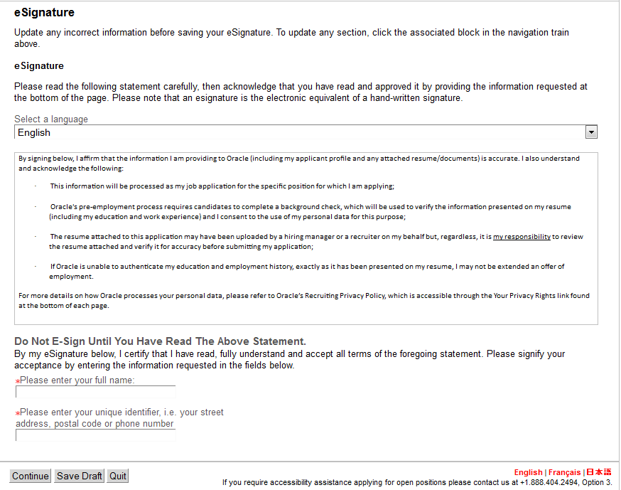
- You will then be asked to complete the eSignature page. Please read the information listed carefully. Enter your full, legal name at the bottom of the page. Enter a unique identifier and then click Continue.
- You will be directed to the Summary. Review your information for accuracy. You can edit any portion by clicking the Edit text next to each header. Click Submit when ready.
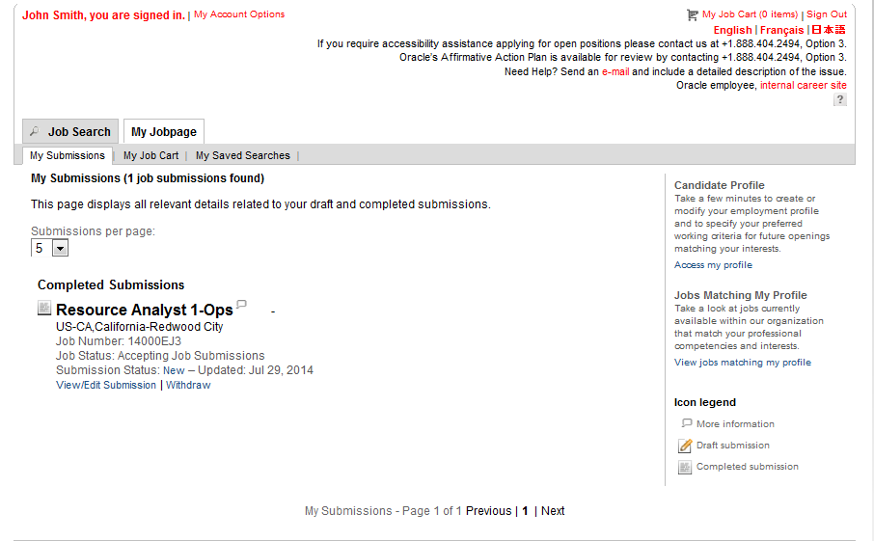
- You will be redirected to a Thank you page indicated that your job submission has been completed.
! Tip: You can review the status of your application at any time, by clicking the My JobPage tab. Here you can review positions that you have applied to and you can make edits to your job submission if necessary.
Thank you for applying to Oracle!

